Base URL: <https://fantasy.premierleague.com/api/>

1. **General Information**

* Endpoint path: bootstrap-static/
* Full URL: <https://fantasy.premierleague.com/api/bootstrap-static/>
* Description: This endpoint returns general information about the FPL game divided into these sections:
  + events: Basic information of every Gameweek such as average score, highest score, top scoring player, most captained, etc.
  + game_settings: The game settings and rules. (not important)
  + phases: Phases of FPL season. (not really important)
  + teams: Basic information of current Premier League clubs.
  + total_players: Total FPL players.
  + elements: Information of all Premier League players including points, status, value, match stats (goals, assists, etc.), ICT index, etc.
  + element_types: Basic information about player’s position (GK, DEF, MID, FWD).

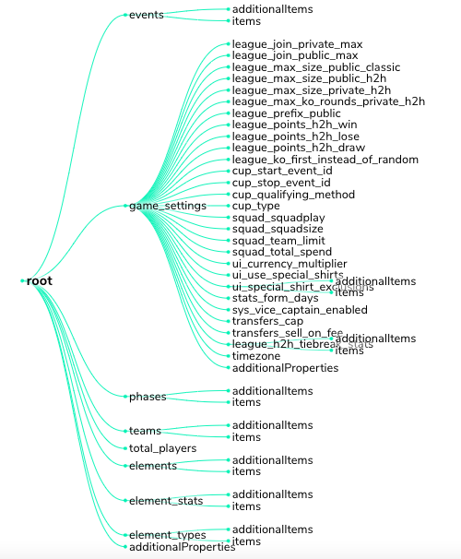

1. **Fixtures**

* Endpoint path: fixtures/
* Full URL: <https://fantasy.premierleague.com/api/fixtures/>
* Description:This endpoint returns a JSON array which contains every fixture of the season. To get fixtures for specific Gameweek, you can add a value parameter after the endpoint path (ex: [fixtures?event=1](https://fantasy.premierleague.com/api/fixtures?event=1)). Now here’s the explanation of some of the JSON elements:
  + Event: refers to the event id in [events](https://medium.com/@frenzelts/fantasy-premier-league-api-endpoints-a-detailed-guide-acbd5598eb19#ac42)section of the bootstrap-static data.
  + team_a and team_h: refers to the team id in [teams](https://medium.com/@frenzelts/fantasy-premier-league-api-endpoints-a-detailed-guide-acbd5598eb19#2feb)section of the bootstrap-static data. team_a for the away team and team_h for the home team.
  + team_h_difficulty and team_a_difficulty: is the FDR value calculated by FPL.
  + Stats: contains a list of match facts that affect points of a player. It consists of goals_scored, assists, own_goals, penalties_saved, penalties_missed, yellow_cards, red_cards, saves, bonus, and bps data.
  + Value: is the amount and element refers to the element id in [elements](https://medium.com/@frenzelts/fantasy-premier-league-api-endpoints-a-detailed-guide-acbd5598eb19#3a0d)section of the bootstrap-static data. For example, we can see goals_scored data from the away team. These information can be read as: Aubameyang, Lacazette, and Gabriel each scored one goal for the away team (which is Arsenal).

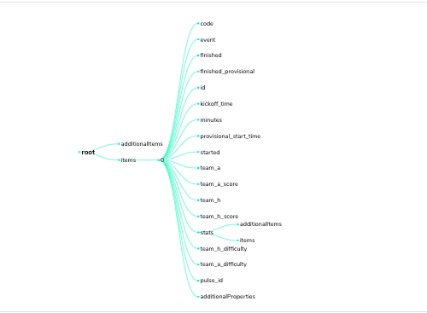

1. **Player’s Detailed Data**

* Endpoint path: element-summary/{element_id}/
* Full URL: [https://fantasy.premierleague.com/api/element-summary/{element_id}/](https://fantasy.premierleague.com/api/element-summary/%7belement_id%7d/)
* Example: <https://fantasy.premierleague.com/api/element-summary/4/>
* Description: This endpoint returns a player’s detailed information divided into 3 section:
  + fixtures: A list of player’s remaining fixtures of the season. Each fixture object consists of these information below:
  + history: A list of player’s previous fixtures and its match stats.
  + history_past: A list of player’s previous seasons and its seasonal stats.

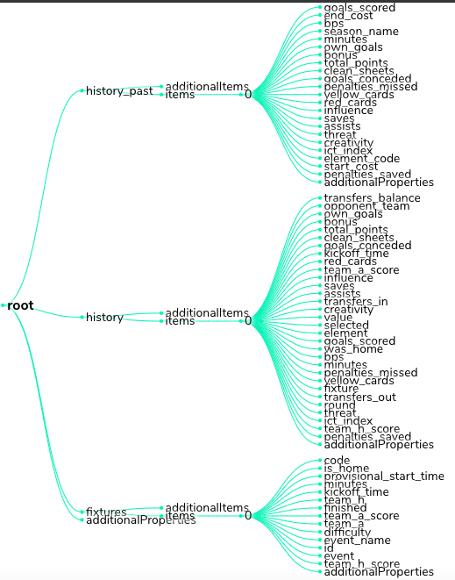

1. **Gameweek Live Data**

* Endpoint path: event/4/live/
* Full URL: [https://fantasy.premierleague.com/api/event/{event_id}/live/](https://fantasy.premierleague.com/api/event/%7bevent_id%7d/live/)
* Example: <https://fantasy.premierleague.com/api/event/4/live/>
* Description: This endpoint returns a list of players’ information in that specific Gameweek. Each element is divided into three section:
  + id: Refers to the element id in [elements](https://medium.com/@frenzelts/fantasy-premier-league-api-endpoints-a-detailed-guide-acbd5598eb19#3a0d) section of the bootstrap-static data.
  + stats: Player’s match stats including goals, assists, etc.
  + explain: Breakdown of a player’s event points.

1. **Manager/User Basic Information**

* Endpoint path: entry/{manager_id}/
* Full URL: [https://fantasy.premierleague.com/api/entry/{manager_id}/](https://fantasy.premierleague.com/api/entry/%7bmanager_id%7d/)
* Example: <https://fantasy.premierleague.com/api/entry/565066/>
* Description: This endpoint returns manager’s (or FPL user’s) basic information. From here you can see the leagues that you joined (or someone with id that you use). You can see the league type, your (or the user’s) rank in the league, and the previous rank. For the league type, s is for public league and x is for private league.

1. **Manager/User’s History**

* Endpoint path: entry/{manager_id}/history
* Full URL: [https://fantasy.premierleague.com/api/entry/{manager_id}/history/](https://fantasy.premierleague.com/api/entry/%7bmanager_id%7d/history/)
* Example: <https://fantasy.premierleague.com/api/entry/565066/history/>
* Description: This endpoint returns a manager’s data from previous Gameweeks (current), previous seasons (past), and chips that already used during this season.

1. **Classic League Standings**

* Endpoint path: leagues-classic/{league_id}/standings
* Full URL: [https://fantasy.premierleague.com/api/leagues-classic/{league_id}/standings](https://fantasy.premierleague.com/api/leagues-classic/%7bleague_id%7d/standings)
* Example: [https://fantasy.premierleague.com/api/leagues-classic/119928/standings](https://fantasy.premierleague.com/api/leagues-classic/119928/standings?page_standings=1)
* Description: This endpoint returns the classic league standings. The entry value refers to the manager id, event_total is the event points, and total is the total points. One classic league may contain large amount of members (especially public leagues), so this endpoint might not return the full data. To retrieve more data, you can use a page_standing parameter after the endpoint path (ex: standings?page_standings=2) just like a pagination.

1. **My Team (requires authentication)**

* Endpoint path: api/my-team/{manager_id}/
* Full URL: [https://fantasy.premierleague.com/api/my-team/{manager_id}/](https://fantasy.premierleague.com/api/my-team/%7bmanager_id%7d/)
* Example: <https://fantasy.premierleague.com/api/my-team/565066/>
* Description: This API call requires authentication.
  + picks: A list of players you have picked in your team.
  + chips: A list of chips that you have/haven’t used.
  + transfers: Your team’s last transfer information.